Multithreading (threading module)

Types of applications
- Single tasking applications
- Multitasking applications

Task is nothing but an operation performed by application.

Single tasking applications
An application or program allows to perform single operation at a time is called single task application.

Default flow of execution of program is sequential

def task1():
print("this is task1")

def task2():
print("this is task2")

def task3():
print("this is task3")

task1()
task2()
task3()

Output
this is task1
this is task2
this is task3

until execution of one task, it cannot call another task

Multitasking application
An application which allows to perform more than task or operation simultaneously or concurrently is called multitasking application.

Advantage of multitasking applications
- Efficiency
- Utilization of CPU idle time

These multitasking applications are developed using thread concept.
In multitasking application each task is defined as thread (OR) each operation represented as thread.

What is thread?
A thread is independent part of execution within program
A thread perform operation independent of other operations or threads
Execution of more than one thread simultaneously or concurrently is called multithreading

How to create a thread?
For creating or working threads, python provided a default module called threading. Threading module provides infrastructure for building or creating threads.

In python threads are created in 2 ways
- Function based thread
- Class based thread

For developing threads, threading module provided Thread class.

Function based thread
A thread can be created using function.
Basic steps for developing function based threads
- Create a function
- Create Thread class object with target as created function
- Start the thread
Example:
import threading
def even():
for num in range(1,21):
if num%2==0:
print(f'EvenNo:{num}')

def odd():
for num in range(1,21):
if num%2!=0:
print(f'OddNo:{num}')

t1=threading.Thread(target=even)
t2=threading.Thread(target=odd)
t1.start()
t2.start()

Output
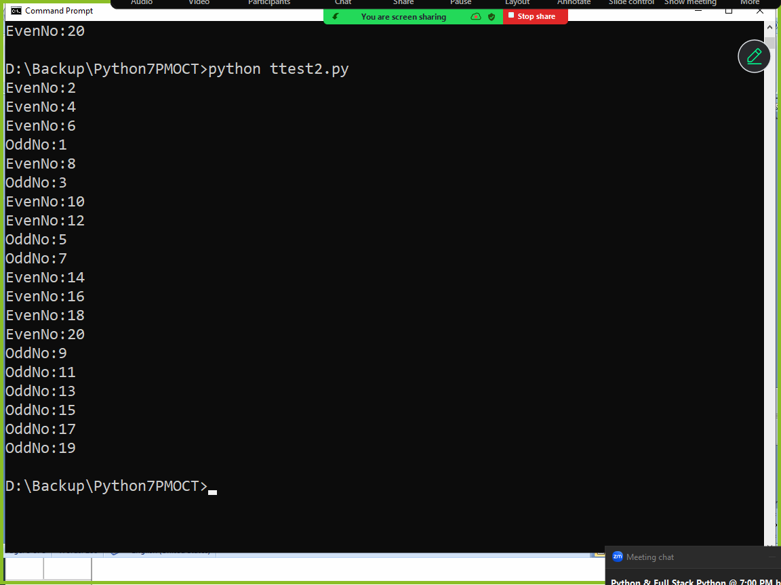

Thread scheduling is done by thread scheduler provided by python runtime (python virtual machine)

Types of thread schedulers
- Time Slicing
- Priority based
In time slicing every thread is given a predefined time
Thread executed using predefined time, after execution it schedule again by giving predefined time.

There will be context switching between one thread and another thread.

Example:
import threading
def even(x,y):
for num in range(x,y):
if num%2==0:
print(f'EvenNo:{num}')

def odd(x,y):
for num in range(x,y):
if num%2!=0:
print(f'OddNo:{num}')

t1=threading.Thread(target=even,args=(1,21))
t2=threading.Thread(target=odd,args=(1,21))
t1.start()
t2.start()

Output
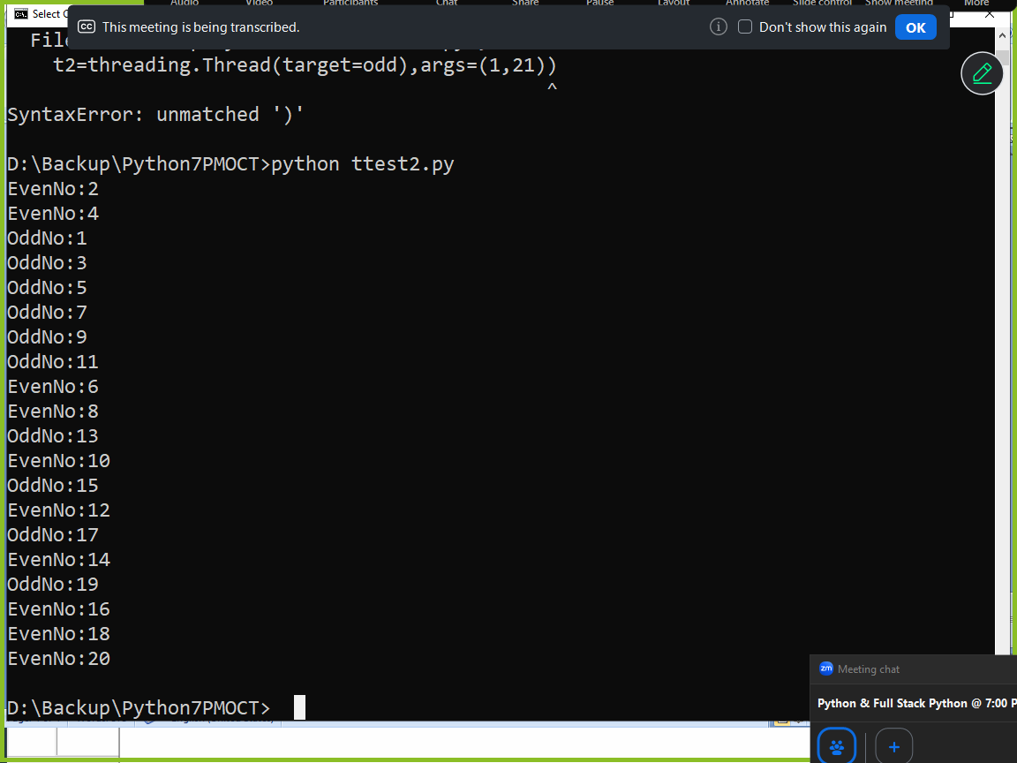

Example:
import threading
def even(x,y):
for num in range(x,y):
if num%2==0:
print(f'EvenNo:{num}')

def odd(x,y):
for num in range(x,y):
if num%2!=0:
print(f'OddNo:{num}')

t1=threading.Thread(target=even,kwargs={'x':1,'y':21})
t2=threading.Thread(target=odd,kwargs={'x':1,'y':21})
t1.start()
t2.start()

Output
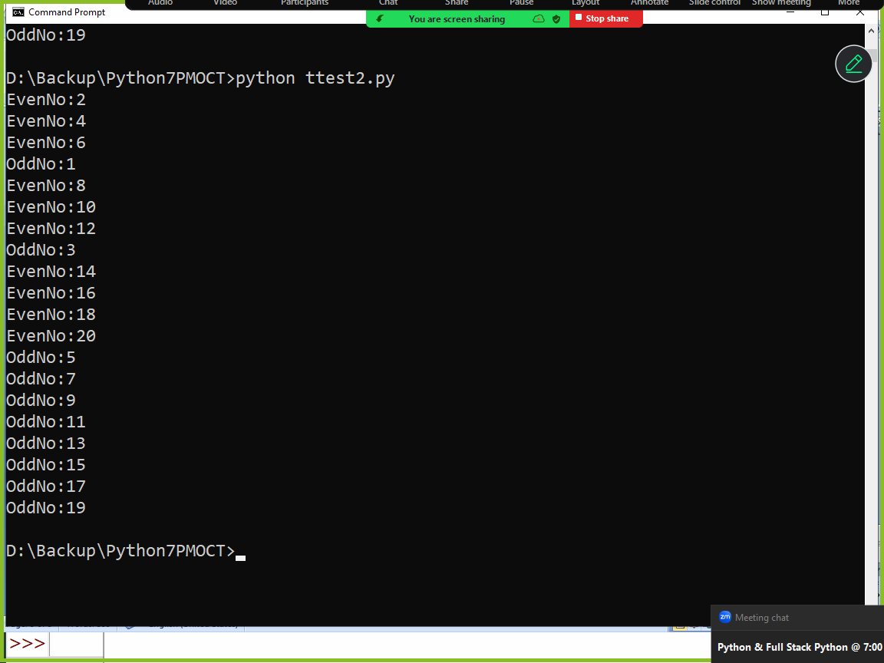

Class based thread
A thread can be developed using class (object oriented programming)

Basic steps for creating class based thread
- Develop a class by inheriting Thread class
- Override run() method of Thread class, which contain the operation performed by thread
- Create object of sub class
- Start the thread

Example:
import threading

class EvenThread(threading.Thread):
def run(self):
for num in range(1,21):
if num%2==0:
print(f'EvenNo {num}')

class OddThread(threading.Thread):
def run(self):
for num in range(1,21):
if num%2!=0:
print(f'OddNo {num}')

t1=EvenThread()
t2=OddThread()
t1.start()
t2.start()

Output
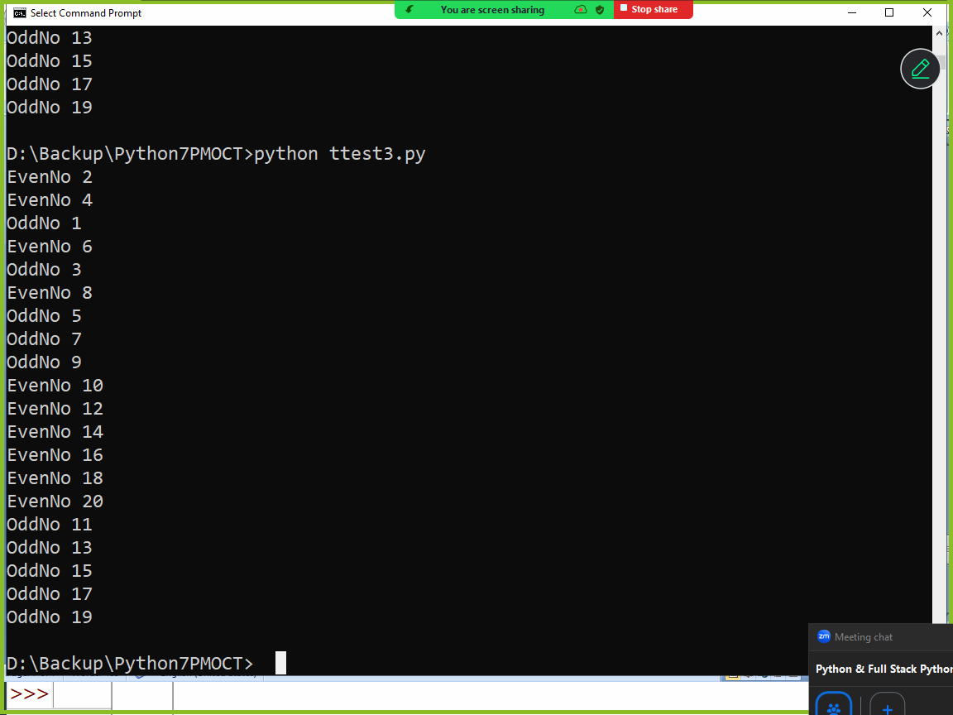

Life Cycle of Thread
Thread execution is managed by python runtime system and thread is having different stages or states

- New Born State
- Runnable State
- Running State
- Idle State
- Dead State

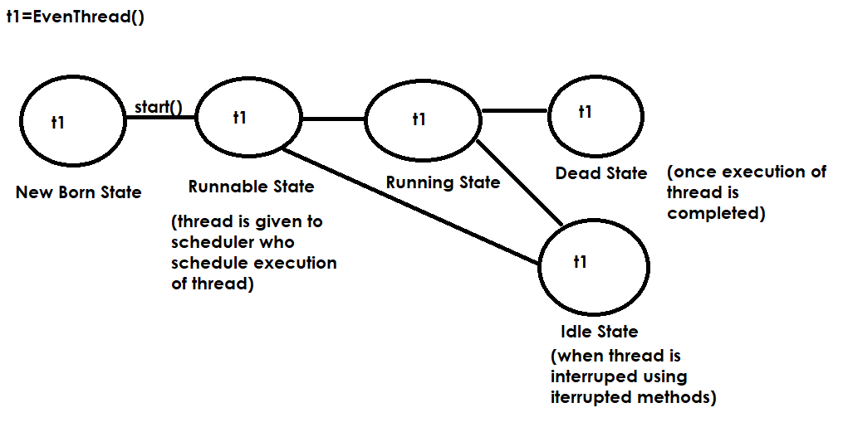

join()
join() method is interrupted method
if join method of thread is called, it waits until execution another thread is completed.
If thread1 calls join method of thread2, thread1 stops until thead2 execution is completed.

Note: every program is executed as one thread within PVM process.

Example:
import threading

t=threading.current_thread()
print(t.name)

Output
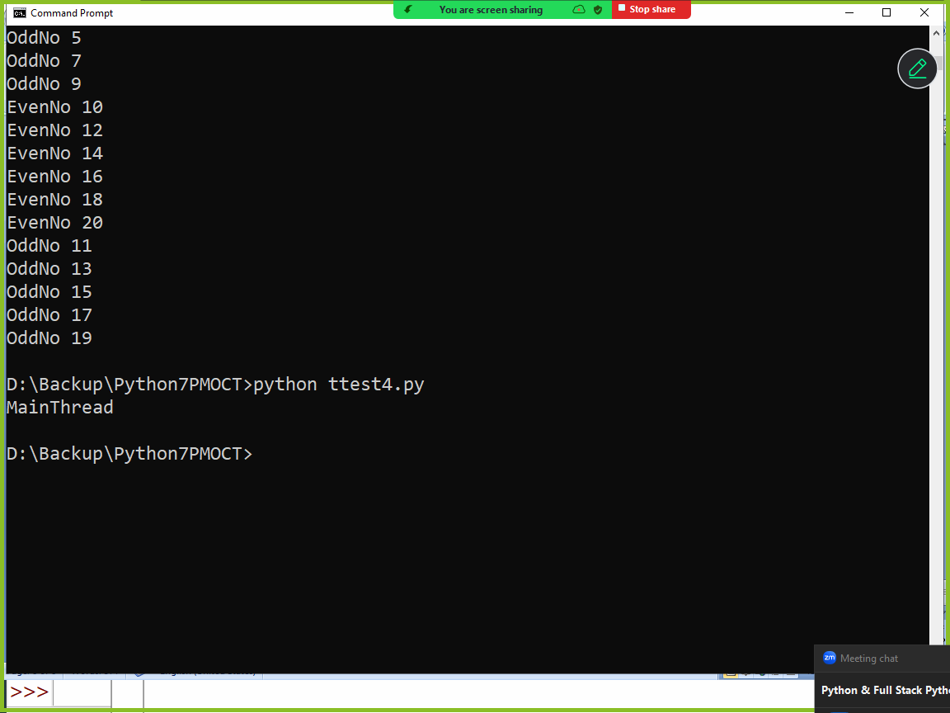

Example:
import threading

def hello():
for i in range(10):
print("Hello")

t1=threading.Thread(target=hello)
t1.start()
for j in range(10):
print("Bye")

Output
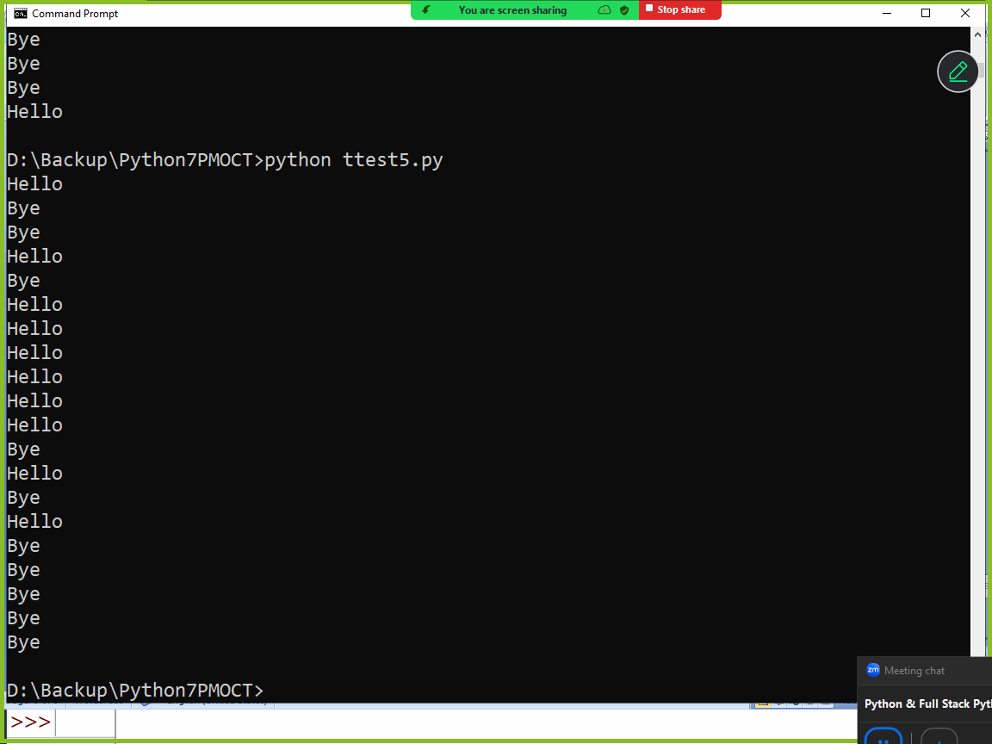

Example:
import threading

def hello():
for i in range(10):
print("Hello")

t1=threading.Thread(target=hello)
t1.start()
t1.join()
for j in range(10):
print("Bye")

Output
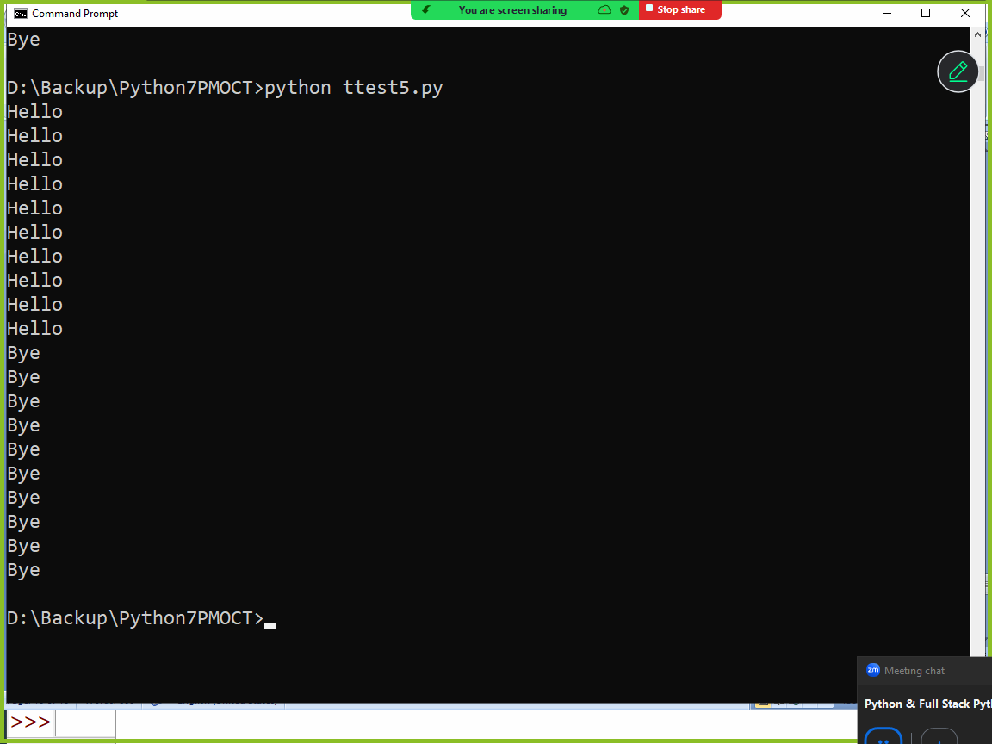

Example:
import threading

total=0
def sum_values():
global total
for num in range(1,1000):
total+=num

#MainThread
t1=threading.Thread(target=sum_values)
t1.start()
t1.join()
print(f'Total of 1-1000 numbers is {total}')

Output
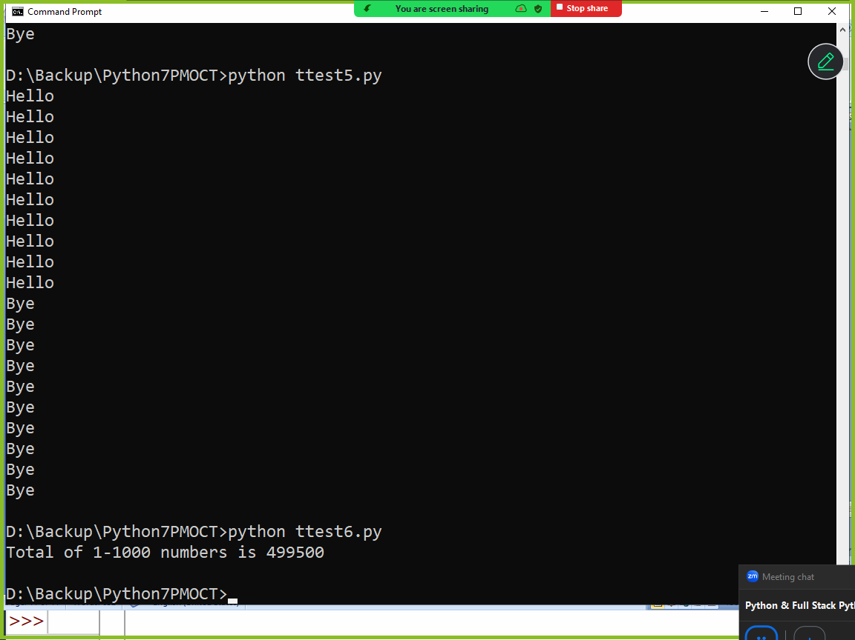

Thread Synchronization
In Python, thread synchronization is a mechanism used to coordinate the execution of multiple threads to ensure they do not interfere with each other when accessing shared resources.
Without synchronization, threads can experience race conditions, where the final outcome depends on the unpredictable timing of thread execution, often leading to data corruption or inconsistent results or wrong result.

Why Synchronization is Necessary
Prevent Race Conditions: Ensures that only one thread can modify shared data at a time.
Data Consistency: Coordinates access so threads don't read or write data in ways that lead to incorrect results.
Ordered Execution: Allows you to control the sequence in which certain tasks are completed.

Synchronization allows developing thread safe applications.
In python synchronization is done using Lock class or object

Lock class or object
Lock object provided 2 methods
- acquire()
- release()
A thread acquires lock and performs operations and releases lock using release method.
If a thread acquires the lock of object other threads cannot access lock, until this thread release the lock.

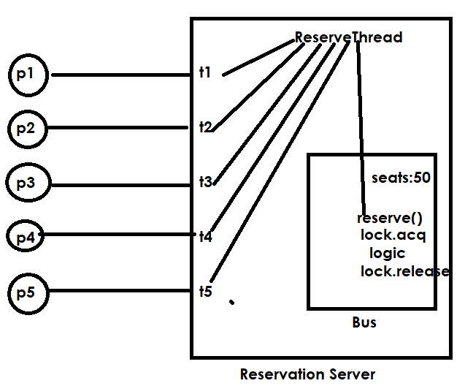

import threading
class Bus:
def __init__(self):
self.seats=50
self.l=threading.Lock()
def reserve(self,name,n):
self.l.acquire()
for i in range(n):
self.seats=self.seats-1
print(f'{name} your seats reserved available seats are {self.seats}')
self.l.release()

class ReserveThread(threading.Thread):
def __init__(self,b,name,s):
super().__init__()
self.bus=b
self.name=name
self.s=s
def run(self):
self.bus.reserve(self.name,self.s)

# Reservation Server
bus1=Bus()
t1=ReserveThread(bus1,"naresh",10)
t2=ReserveThread(bus1,"suresh",15)
t1.start()
t2.start()

Output
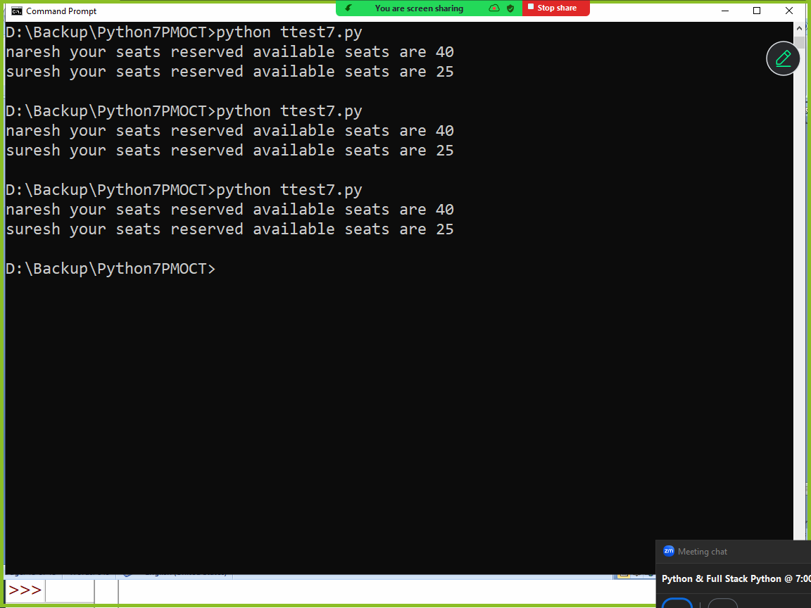

Garbage Collection
In python memory management is done automatically.
Memory management consist of 2 things
- Allocation of memory (Creating objects)
- De-allocation of memory (Deleting objects)

In python creating of objects done by python programmer
In python deleting of objects are not done by python programming, it is done a service provided by python called garbage collector

In python memory management or deleting of objects are done automatically.

Garbage collector works using a concept called reference count
Garbage collector removes or deletes all the objects whose reference count is zero.
An object whose reference count is zero is called unreferenced objects or unused objects.
An object bind with variable is called referenced object
An object which dose bind with any variable is called unreferenced and these objects are removed by garbage collector.

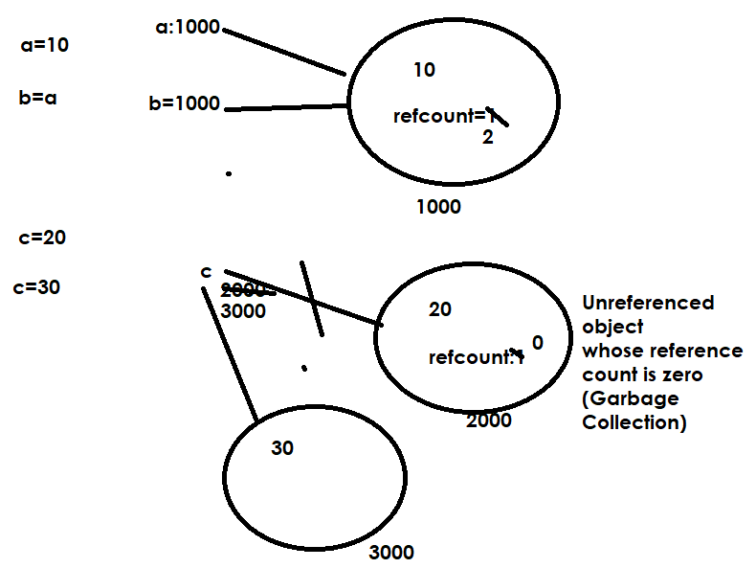

# Creating objects and finding reference count
import sys

class Employee:
def __init__(self,eno,en):
self.empno=eno
self.ename=en
print("Employee object is created")

emp1=Employee(1,"naresh")
emp2=Employee(2,"suresh")
emp3=emp1
c1=sys.getrefcount(emp1)
print(c1)
c2=sys.getrefcount(emp2)
print(c2)

Output
Employee object is created
Employee object is created
3
2

Example:
# Creating objects and finding reference count
import sys

class Employee:
def __init__(self,eno,en):
self.empno=eno
self.ename=en
print("Employee object is created")

emp1=Employee(1,"naresh")
emp2=Employee(2,"suresh")
emp3=emp1
c1=sys.getrefcount(emp1)
print(c1)
c2=sys.getrefcount(emp2)
print(c2)
emp1=None
emp2=None
emp3=None

Destructor
Destructor is a magic method which is executed automatically before object is deleted by garbage collector
The name of the destructor is __del__
Destructor is used to de-allocate resources allocated by constructor.

Example:
class Alpha():
def __init__(self):
print("Alpha object is created")
def __del__(self):
print("Alpha object is deleted")

a1=Alpha()
a2=Alpha()
a1=None
a2=None

Output
Alpha object is created
Alpha object is created
Alpha object is deleted
Alpha object is deleted

Example:
class Alpha():
def __init__(self):
print("Alpha object is created")
def __del__(self):
print("Alpha object is deleted")

def fun1():
a1=Alpha()
a2=Alpha()

fun1()

Output
Alpha object is created
Alpha object is created
Alpha object is deleted
Alpha object is deleted

Example:
class Alpha():
def __init__(self):
print("Alpha object is created")
def __del__(self):
print("Alpha object is deleted")

a1=Alpha()
a3=a1
a2=Alpha()
del a1
del a2

Output
Alpha object is created
Alpha object is created
Alpha object is deleted

pythonbygupta@gmail.com

